

NEW HORIZON WORLD ACADEMY, KALYAN (W)
ACADEMIC YEAR 2025-2026
School Affiliation No: MA219

Date: 20-01-26
Circular No- NHWA/SVSS/ACD 2025-26/62

Subject: - Rangotsav Competition– Level II

Dear Parents,
Greetings from New Horizon World Academy Kalyan!

We are pleased to inform you that New Horizon World Academy, Kalyan is organizing Rangotsav Competition for students of Grade I and Grade II on
22nd January, 2026 and for the Pre- Primary Section on 23rd January, 2026

Timings:
Morning Session: 9:00 a.m. to 11:00 a.m.
Afternoon Session: 1:00 p.m. to 3:00 p.m.

Instructions:

- Students must carry their own art materials as per the activity assigned (e.g., Thumb painting, watercolours, etc.).

- Refreshments and drinking water will be provided to all students during the competition.

We look forward to your enthusiastic participation.

With warm regards,
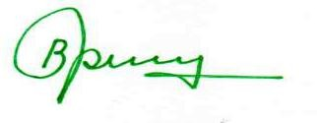
Mrs. Bhawana Trivedi
Principal
New Horizon World Academy

